"Strikes, Smiles, and Chicken Wings: The Beginning of an Obsession"
Mikey Beaven – Kadena, AFB 2010

Let me tell you about the time Otto and I (Mikey Beaven) went bowling at Emery Lanes on Kadena Air Force base. It all started innocently enough when we decided to grab some chicken wings for lunch. Now, let me just say, the chicken wings at that bowling alley were legendary, and there was at least a 15-minute wait for those delicious bites of heaven.

So, there we were, hungry and waiting, when Otto, always up for some fun, suggested, "Hey, why don't we just bowl a game while we wait?" I went to my car and grabbed my ball and shoes. Well, you know how it goes; Otto only plays to win.

I was showing some serious bowling skills and edged out Otto with a score of 227 to 225. Otto, with his infectious laugh, contested the match, demanding, "Best 2 out of 3!" So, we geared up for round two.

Round two was neck and neck, but this time, Otto had the upper hand, barely beating me with a score of 215 to 209. With the score tied, you could feel the tension in the air. Otto was giving me that half serious and half joking competitive smirk.
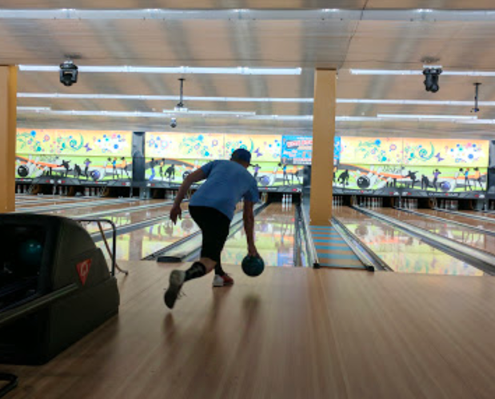
As we started the third and final round, Otto was in full competitive-teasing mode. He kept saying stuff like, "Mikey, your arm tired yet?" and even tried to blame the lane conditions, saying, "There's too much wax on this lane; let's switch!" He even asked if my personal bowling ball was legal and claimed that it was an unfair advantage. I was having blast, not sure how much fun he was genuinely having. Even though we were bowling our hearts out and, might I add, we totally lost track of time.
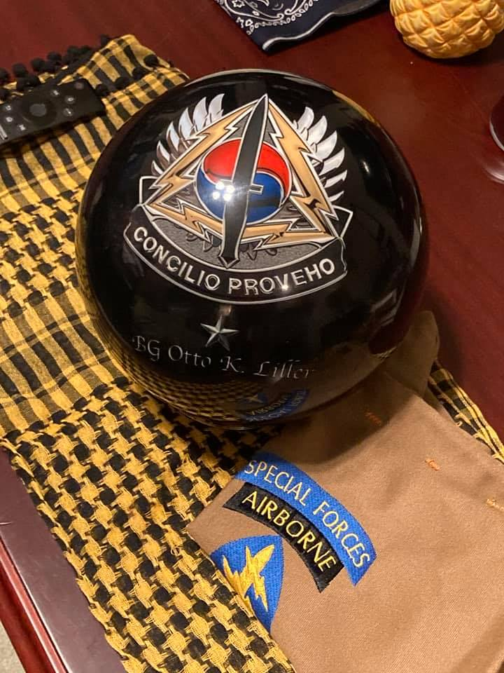
By the eighth frame of that third round, I was up by just 10 pins and laying on the harassment thick. But Otto, with that trademark smile, started talking about baseball and the World Series, saying, "It's not decided in 3 games. Best out of 5, that's how you determine a true champion."

And guess what? We both were so engrossed in the bowling showdown that we completely missed a meeting we were supposed to attend. But who could blame us? It was an epic battle of wits and skill.

In the end, I managed to beat Otto four out of five rounds, and we were laughing and playfully talking smack to each other the whole time. It was a day to remember, for sure.

But here's the kicker: it was the only time I would ever beat Otto at bowling. Every time after that, if you ever caught Otto at the Kadena Air Force Base bowling alley, he was there, practicing and putting in the work, determined never to be beaten again. Two weeks after that match, Otto was outfitted with a new custom ball, shoes, and bag. And if you dared bring up the time I beat him, Otto would just grin and say, "Why are you bringing up old stuff? Those days are long gone!"

